

A PROJECT REPORT

ON

“Smart Door Automation System using IR Sensor and Servo Motor”

A project report submitted in partial fulfillment of the requirements for the degree of Bachelor of Technology in Computer Science and Engineering

BACHELOR OF TECHNOLOGY COMPUTER SCIENCE AND ENGINEERING

Submitted By
Aditi Sawarkar & 24070521118
Siddhi Godshelwar & 25070521506
Samruddhi Satav & 24070521117

UNDER THE GUIDANCE OF

Rajeshwar Balla

DEPARTMENT OF COMPUTER SCIENCE AND ENGINEERING
AY 2025-26

DEPARTMENT OF COMPUTER SCIENCE AND ENGINEERING

DEPARTMENT OF COMPUTER SCIENCE AND ENGINEERING

CERTIFICATE
This is to certify that the Project work entitled “Smart Door Automation System using IR Sensor and Servo Motor” is carried out by the Aditi Sawarkar, in partial fulfillment for the award of the degree of Bachelor of Technology in Computer Science and Engineering, Symbiosis International (Deemed University), Pune during the academic year 2025-2026.

Name of Mentor
Rajeshwar Balla

Dr. Gaurav Londhe
Associate Professor
Hack-O-Week In-Charge

Dr. Sagar Kumar Badhiye
HoD, Dept. of CSE,
SIT Nagpur

Dr. Bhupesh Kumar Dewangan

DECLARATION
I hereby declare that the project titled “Smart Door Automation System using IR Sensor and Servo Motor” submitted to Symbiosis Institute of Technology, Constituent of Symbiosis International (Deemed University) Pune for the award of the degree of Bachelor of Technology in Computer Science and Engineering is a result of original research carried out by me. I understand that my report may be made electronically available to the public. It is further declared that the project report or any part thereof has not been previously submitted to any University or Institute for the award of any degree or diploma.
Name of All Student(s) : Aditi Sawarkar, Siddhi Gobshelwar, Samruddhi Satav
PRN: 24070521118,25070521506,24070521117
Degree: Bachelor of Technology in CSE
Department: Computer Science and Engineering
Title of the project : Smart Door Automation System using IR Sensor and Servo Motor

_________________________________
(Signatures of the All Students)
Date: 11/04/2026

ABSTRACT
The Smart Door Automation System is an intelligent and efficient solution designed to automate the operation of doors using sensor-based technology. The system primarily utilizes an IR proximity sensor to detect the presence of a person approaching the door and a servo motor to control the opening and closing mechanism. The aim of this project is to provide a touchless, convenient, and energy-efficient method for accessing doors in various environments such as homes, offices, hospitals, and public places.
In this system, the IR sensor continuously monitors the surrounding area by emitting infrared radiation. When a person comes within the detection range, the reflected infrared rays are captured by the sensor, which then generates a signal. This signal is sent to the microcontroller, which processes the input and triggers the servo motor to rotate and open the door. After a predefined time delay or when no object is detected, the system automatically commands the servo motor to return to its original position, thereby closing the door. This ensures smooth and automatic operation without requiring any human intervention.
Additionally, the system can be enhanced with event logging functionality to record entry and exit activities, which can be useful for security monitoring and analysis. The design of this system focuses on simplicity, low cost, and ease of implementation, making it suitable for both academic purposes and real-world applications.
Keywords: Smart Door Automation, IR Proximity Sensor, Servo Motor, Microcontroller, Embedded System, Automatic Door System, Contactless Technology, Sensor-Based Control, Home Automation, Event Logging, Automation System, IoT (Future Scope).

TABLE OF CONTENTS
 |  |  |  | Page
Certificate |  |  |  | i
Declaration |  |  |  | ii
Abstract |  |  |  | iv
Table of Contents |  |  |  | v
CHAPTER 1: BACKGROUND AND TECHNICAL OVERVIEW |  |  |  | 1
CHAPTER 2: PROBLEM STATEMENT AND MOTIVATION |  |  |  | 12
CHAPTER 3: NOVELTY AND INNOVATIVE CONTRIBUTIONS
CHAPTER 4: TECHNICAL ADVANTAGES AND PRACTICAL USEFULNESS |  |  |  | 73
CHAPTER 5: DETAILED METHODOLOGY / SYSTEM ARCHITECTURE  CHAPTER 6: PRIOR ART AND RELATED WORK (Literature Survey)  CHAPTER 7: APPLICATIONS AND DEPLOYMENT AREAS |  |  |  | 87
CHAPTER 8: CONCLUSION AND FUTURE SCOPE |  |  |  | 164
REFERENCES ( in IEEE format only)
APPENDICES

Chapter 1: Background and Technical Overview
1.1 Background
In the modern era, automation has become an essential part of daily life, playing a significant role in improving efficiency, convenience, and safety across various sectors. From industrial machinery to household applications, automated systems help reduce human effort and enhance productivity. One of the most common and useful applications of automation is in door control systems, where doors can operate automatically without requiring manual effort.
Traditional door systems require physical interaction, which can be inconvenient in many situations such as when a person is carrying objects or when quick access is needed. Moreover, in environments like hospitals, laboratories, and public places, touching door handles frequently can lead to hygiene concerns and the spread of infections. To overcome these issues, automatic door systems have been developed that provide a contactless and user-friendly solution.
The Smart Door Automation System is designed to address these challenges by using sensor-based technology. It detects the presence of a person and automatically opens or closes the door accordingly. This system not only enhances convenience but also improves accessibility for elderly and physically challenged individuals. Additionally, it supports the concept of smart infrastructure by integrating simple electronic components to create an intelligent system. Due to its low cost and easy implementation, it is suitable for both academic projects and real-world applications.

1.2 Technical Overview
The Smart Door Automation System is built using three main components: an IR proximity sensor, a microcontroller, and a servo motor. These components work together to perform sensing, processing, and actuation functions.
The IR proximity sensor is responsible for detecting the presence of a person near the door. It works by emitting infrared light and sensing the reflected rays when an object comes within its detection range. When a person approaches the door, the reflected infrared signal is captured by the sensor, which then generates an output signal.
This signal is sent to the microcontroller, which acts as the control unit of the system. The microcontroller processes the input received from the sensor and makes a decision based on the programmed instructions. If the presence of a person is detected, it sends a control signal to the servo motor to open the door.
The servo motor is used to control the physical movement of the door. It rotates to a specific angle, such as 90 degrees, to open the door and returns to its original position, such as 0 degrees, to close it. The movement of the servo motor is precise and controlled, ensuring smooth operation of the door.
In addition to the basic functionality, the system can include a timer to control how long the door remains open. It can also log events such as the number of entries and exits or the time at which the door was operated. Optional components like LEDs and buzzers can be added to provide visual and audio indications.
Overall, the system operates in a sequence where the sensor detects the user, the microcontroller processes the information, and the servo motor performs the required action. This integration of hardware and software makes the system efficient, reliable, and suitable for various real-life applications.

CHAPTER 2: PROBLEM STATEMENT AND MOTIVATION
2.1 Problem Statement
In many residential, commercial, and public environments, doors are still operated manually, which can lead to inconvenience, inefficiency, and hygiene concerns. Manual door operation requires physical effort and direct contact, which may not be suitable in situations where a person’s hands are occupied or when quick and easy access is needed. In places such as hospitals, laboratories, and crowded public areas, frequent touching of door handles increases the risk of spreading germs and infections. Additionally, traditional door systems do not provide any intelligent features such as automatic detection, controlled access, or monitoring of entry and exit. This lack of automation can result in inefficient movement of people, especially in high-traffic areas. It also creates difficulties for elderly individuals and physically challenged people who may find it hard to operate doors manually.
2.2 Motivation
The motivation behind developing the Smart Door Automation System arises from the need to improve convenience, safety, and accessibility in everyday environments. With the growing demand for smart and automated systems, there is a strong need to replace traditional manual methods with intelligent solutions that require minimal human effort. One of the key motivating factors is the importance of hygiene and contactless interaction, especially in public places and healthcare environments. An automatic door system reduces the need for physical contact, thereby minimizing the risk of contamination and promoting a safer environment. Another motivation is to assist elderly and physically challenged individuals by providing easy and effortless access.
Chapter 3: Novelty and Innovative Contributions
The Smart Door Automation System presents a simple yet effective approach to automating door operations using basic electronic components. The novelty of this project lies in its combination of affordability, ease of implementation, and practical usability. Unlike complex and expensive automatic door systems used in commercial buildings, this system is designed using low-cost components such as an IR proximity sensor and a servo motor, making it accessible for small-scale and academic applications.
One of the key innovative aspects of this project is the integration of sensing and actuation in a compact and efficient manner. The system not only detects the presence of a user but also responds instantly by controlling the door movement automatically. This real-time interaction enhances user convenience and provides a smooth, contactless experience.
Another important contribution is the inclusion of event logging functionality. The system can be designed to record entry and exit activities, which adds a layer of monitoring and basic security. This feature makes the system more than just an automation tool, extending its usefulness in areas where tracking movement is important.
Additionally, the project provides flexibility for future enhancements such as integration with IoT, mobile applications, or advanced sensors. This scalability makes the system adaptable to modern smart environments. Overall, the project demonstrates how simple technologies can be innovatively combined to create an intelligent, efficient, and user-friendly solution.

Chapter 4: Technical Advantages and Practical Usefulness
The Smart Door Automation System offers several technical advantages that make it an efficient and reliable solution for modern applications. One of the primary advantages is its simplicity in design and implementation. The system uses basic components such as an IR proximity sensor, a microcontroller, and a servo motor, which are easy to integrate and require minimal maintenance. This makes the system cost-effective and suitable for students as well as real-world applications.
Another important advantage is its fast response time. The IR sensor quickly detects the presence of a person, and the microcontroller processes the signal almost instantly, allowing the door to open and close without noticeable delay. The use of a servo motor ensures precise control over the door movement, resulting in smooth and accurate operation.
Overall, the Smart Door Automation System is a practical, low-cost, and scalable solution that demonstrates the effective use of automation technology in everyday life.
CHAPTER 5: DETAILED METHODOLOGY / SYSTEM ARCHITECTURE
The Smart Door Automation System has three parts: input (IR sensor), processing (microcontroller), and output (servo motor). The sensor detects a person and sends a signal to the microcontroller, which activates the motor to open the door. After a short time, the door closes automatically.
Flow: IR Sensor → Microcontroller → Servo Motor

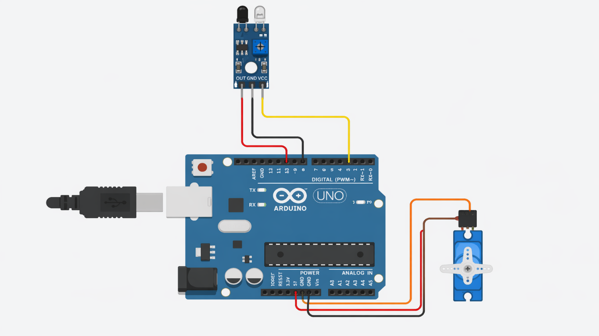
CHAPTER 6: PRIOR ART AND RELATED WORK
Automatic door systems have been widely developed and used in places such as shopping malls, airports, and hospitals. These systems commonly use sensors like infrared, ultrasonic, or motion sensors to detect the presence of a person and open or close doors automatically. Many advanced systems also include features like sliding mechanisms, security access, and remote control.
Previous work in this field has focused on improving accuracy, speed, and security of detection systems. Some systems use PIR sensors for motion detection, while others use ultrasonic sensors for distance measurement. In more advanced applications, technologies like IoT and face recognition are integrated for smart access control.
Compared to these existing systems, the Smart Door Automation System in this project uses a simple IR sensor and servo motor, making it cost-effective and easy to implement. It provides basic automation functionality and can be further enhanced with advanced features in the future.

CHAPTER 7:APPLICATIONS AND DEPLOYMENT AREAS
The Smart Door Automation System can be used in a wide range of environments where automatic and contactless access is required. In residential areas, it can be implemented in smart homes to provide convenience and ease of use. In commercial spaces such as offices and shopping malls, it helps manage the movement of people efficiently and reduces manual effort.
In hospitals and laboratories, the system is especially useful as it ensures hygiene by minimizing physical contact with doors. It can also be deployed in public places like airports, railway stations, and hotels where there is a high flow of people. Additionally, it is beneficial for elderly and physically challenged individuals, as it allows easy access without manual operation.
Overall, the system is suitable for any place that requires automatic, efficient, and user-friendly door control.

CHAPTER 8: CONCLUSION AND FUTURE SCOPE
8.1 Conclusion
The Smart Door Automation System is a simple and effective solution for automating door operations using basic electronic components. It uses an IR sensor to detect the presence of a person and a servo motor to open and close the door automatically. This system reduces manual effort, improves convenience, and provides contactless operation, which is especially useful in maintaining hygiene.
The project demonstrates how sensor-based technology and embedded systems can be combined to create a practical and efficient application. It is cost-effective, easy to implement, and suitable for both academic and real-world use. Overall, the system successfully achieves its objective of providing an automatic and user-friendly door control mechanism.
8.2 Future Scope
The system can be further improved by adding advanced features such as IoT integration for remote monitoring and control. It can also include security features like password access, RFID, or face recognition for restricted entry. More advanced sensors like ultrasonic or PIR sensors can be used to improve detection accuracy.
Additionally, mobile app control and voice command integration can make the system more user-friendly. The system can also be expanded to work with automatic locking mechanisms and real-time data logging. These enhancements can transform the project into a fully smart and secure door automation system suitable for modern smart environments.

References / Bibliography
[1] P. Horowitz and W. Hill, The Art of Electronics, 3rd ed. Cambridge University Press, 2015.
[2] M. Banzi and M. Shiloh, Getting Started with Arduino, 3rd ed. Maker Media, 2014.
[3] S. Monk, Programming Arduino: Getting Started with Sketches, McGraw-Hill, 2016.
[4] “IR Sensor HC-SR04 Datasheet,” HC-SR04 IR Sensor.
[5] “Embedded Systems Overview,” Embedded Systems.
[6] “Automation Systems and Applications,” International Journal of Engineering Research and Technology (IJERT).

